Graded Project

**Cloud basics (Azure)**

Week 11

Table of Content

Business Context 3

Learning Outcome 3

Problem statement 3

1. Create an Azure SQL database with the following specifications 5

a) Database plan: Basic 7

b) Connectivity method: Public Endpoint 7

c) No existing data backup 8

2. Use the query editor to create a table with the following fields and datatypes 9

a) Name: String 9

b) Author: String 9

c) ISBN: Integer 9

d) Price: Integer 9

e) Number of copies available: Integer 9

3. Insert the values into the table 9

4. Write queries to retrieve the following data 11

a) Total price of all the books authored by Stephen King 11

b) List of all the Books priced above 500 12

c) Number of books with less than 3 copies available 12

# **Business Context**

A library will have thousands of books available and hundreds of borrowers every single day. This leads to a high number of transactions that need to be tracked and queried very fast. The database used should, therefore also be designed as such.

In this exercise, you deploy an SQL database on Azure according to the given specifications

# Learning Outcome

1) Deploy an Azure SQL database

2) Connect to the database using the query editor

3) Run DDL and DML queries on tables

# Problem statement

1) Create an Azure SQL database with the following specifications

a) Database plan: Basic

b) Connectivity method: Public Endpoint

c) No existing data backup

2) Use the query editor to create a table with the following fields and datatypes

a) Name: String

b) Author: String

c) ISBN: Integer

d) Price: Integer

e) Number of copies available: Integer

3) Insert the following values into the table

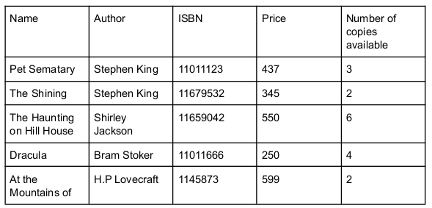

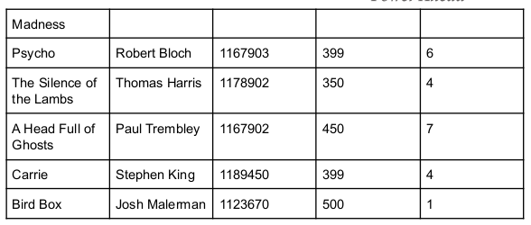

4) Write queries to retrieve the following data

a) Total price of all the books authored by Stephen King

b) List of all the Books priced above 500

c) Number of books with less than 3 copies available

## Create an Azure SQL database with the following specifications

Firstly, we create SQL Server

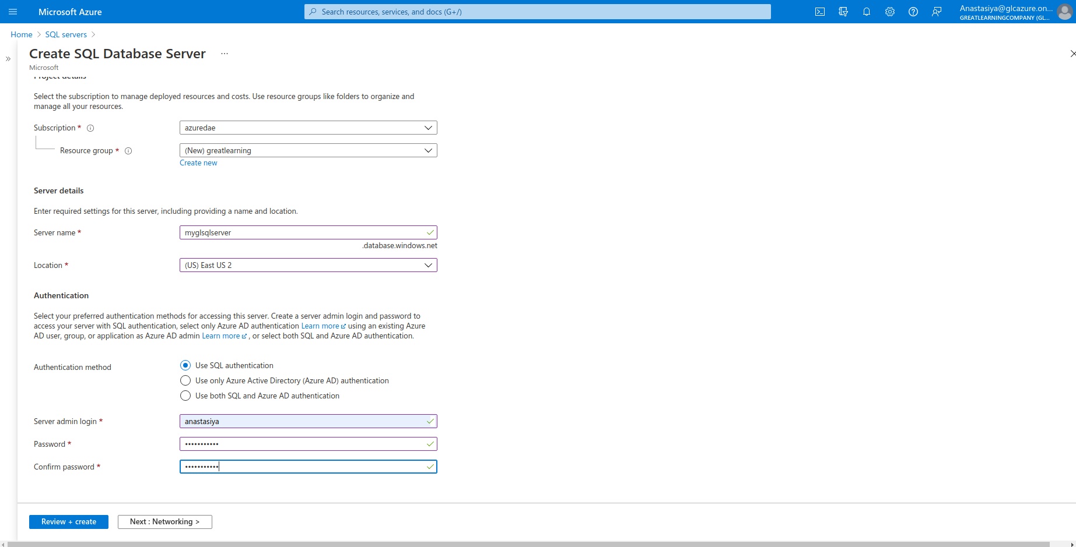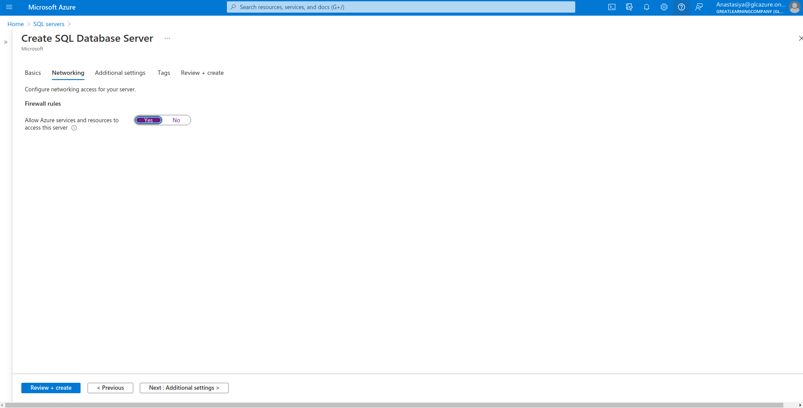

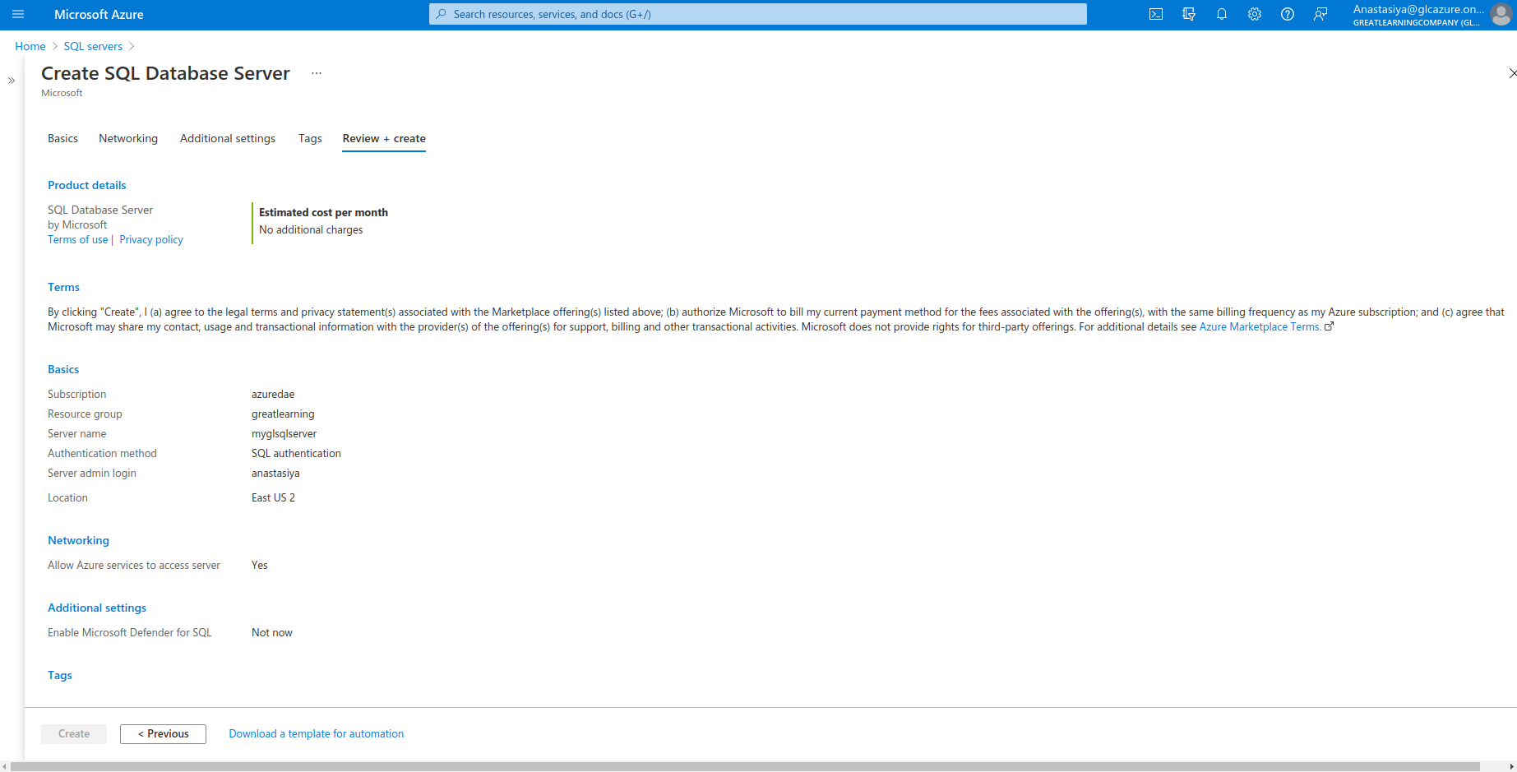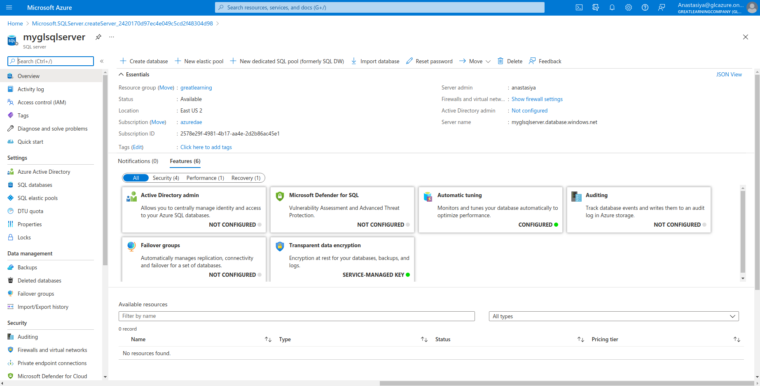Afrer creation SQL Server

### a) Database plan: Basic

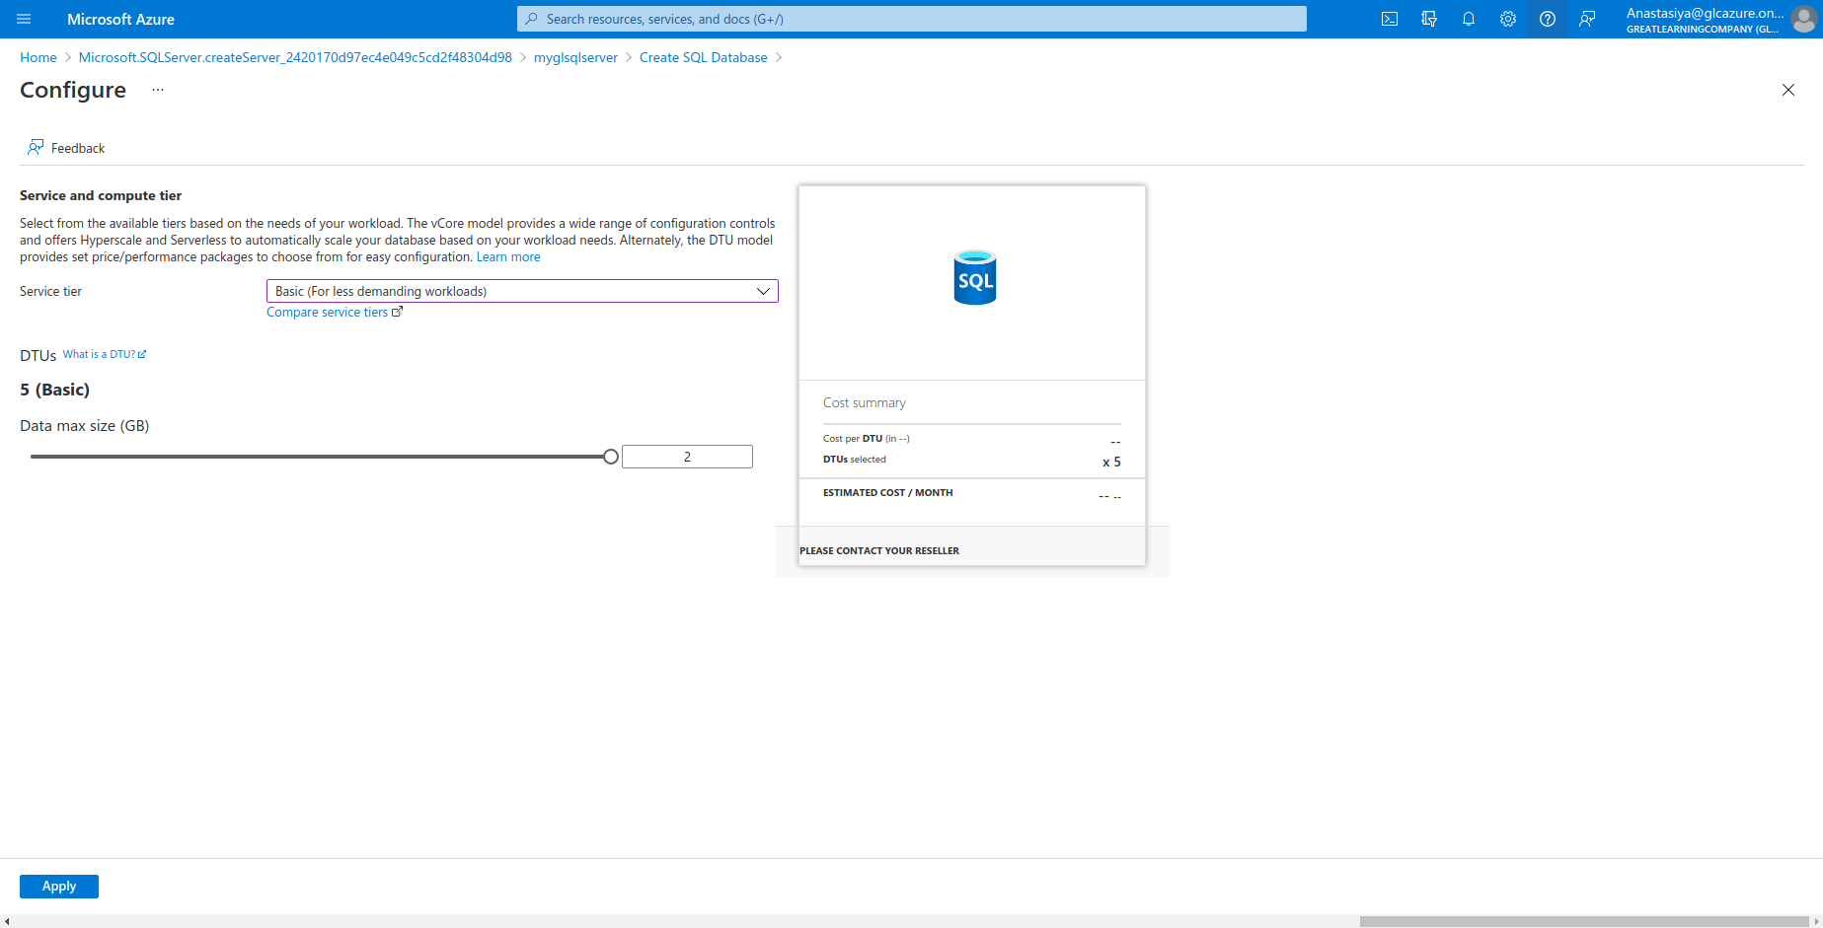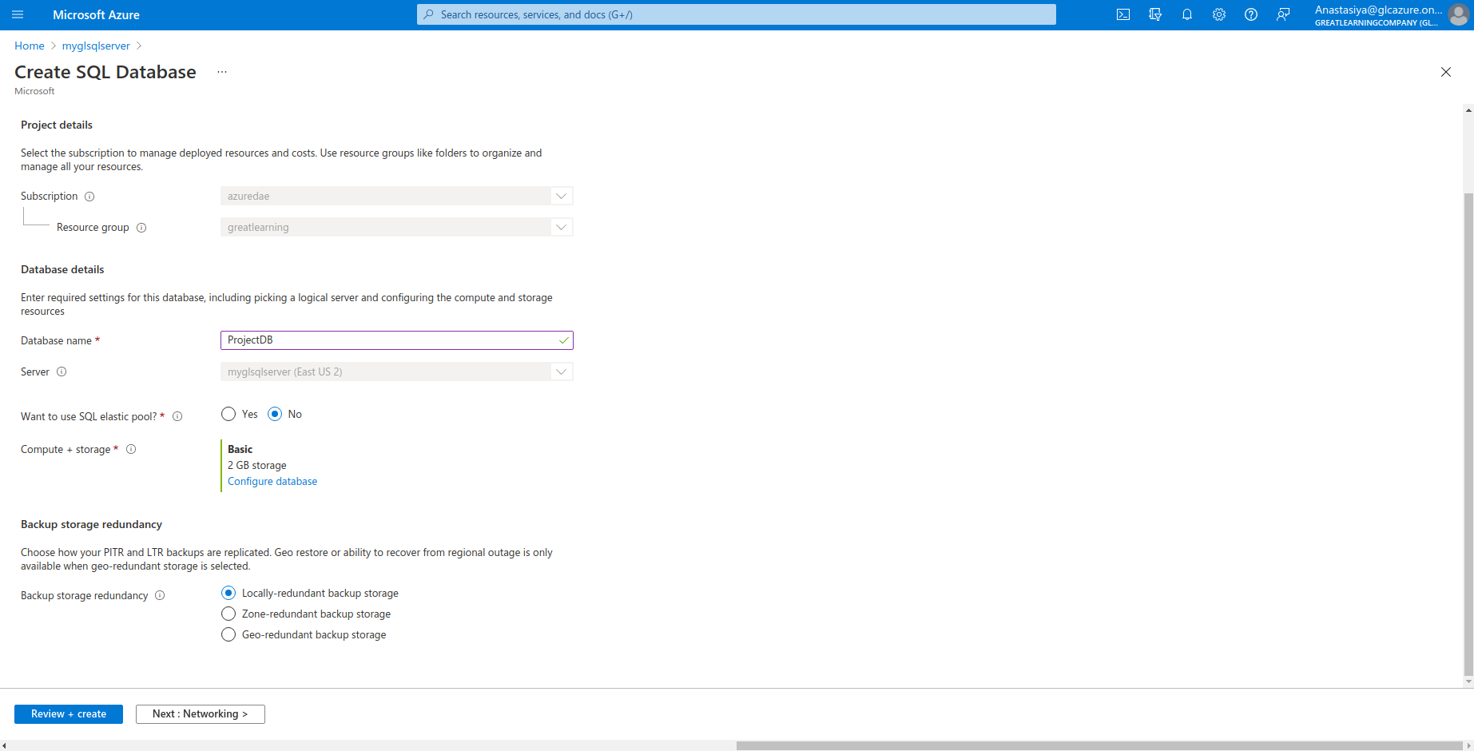

### b) Connectivity method: Public Endpoint

I have created new rule with my (client) IP address

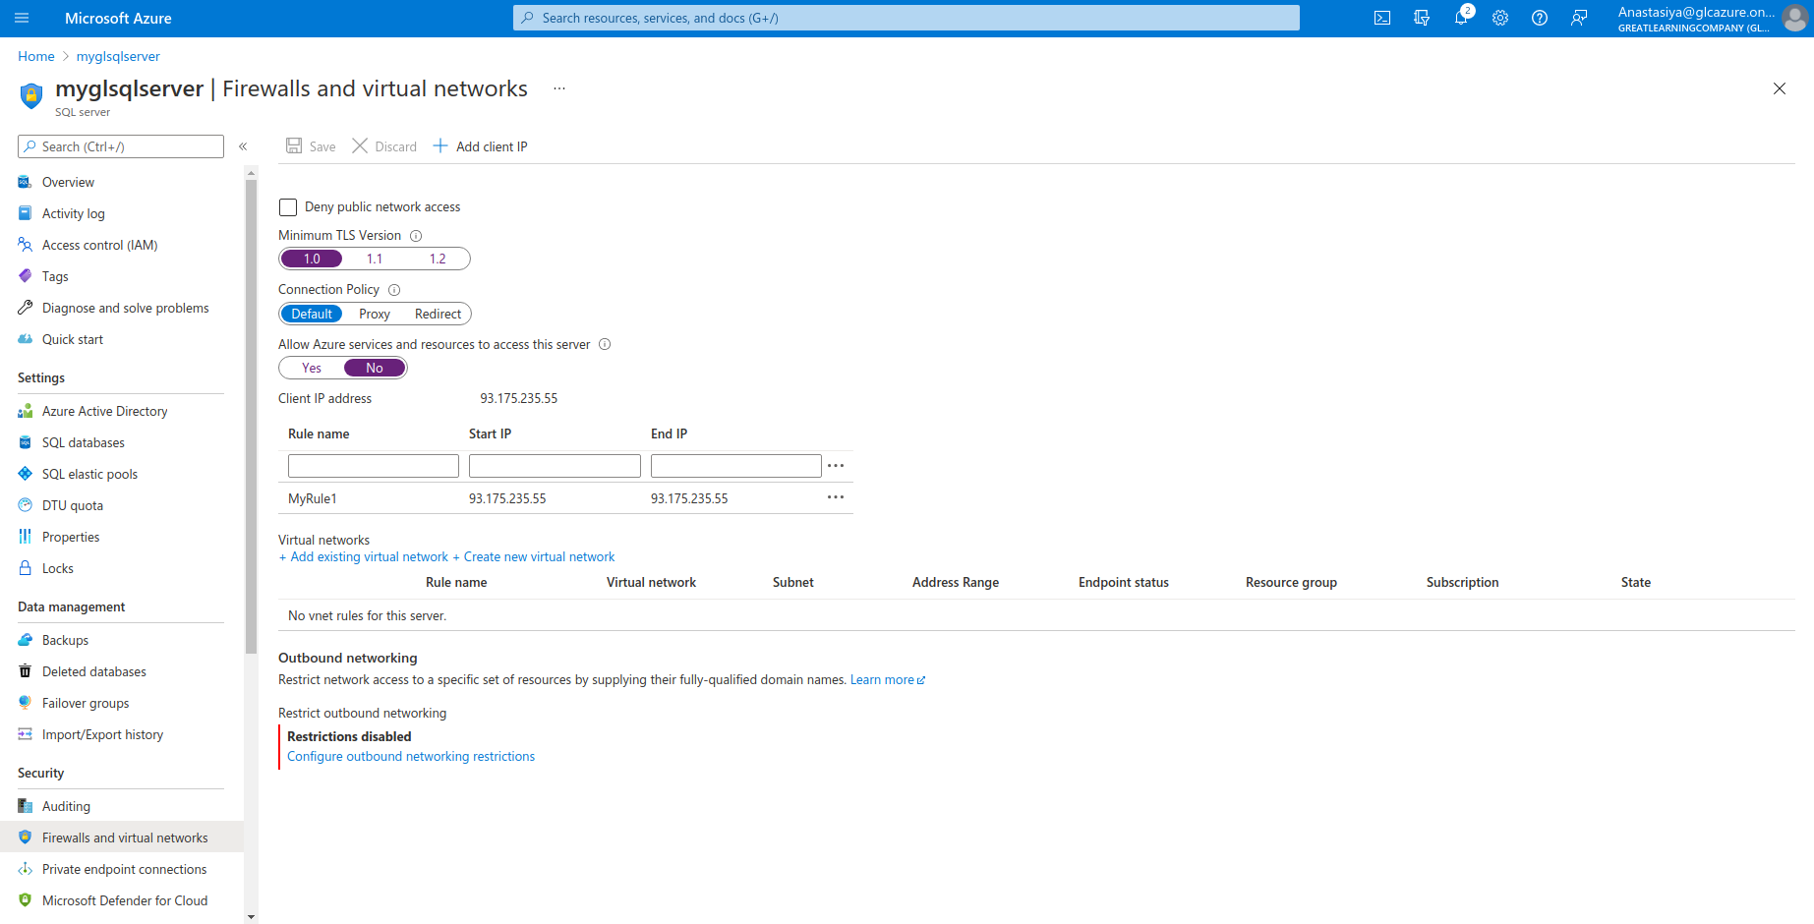

### c) No existing data backup

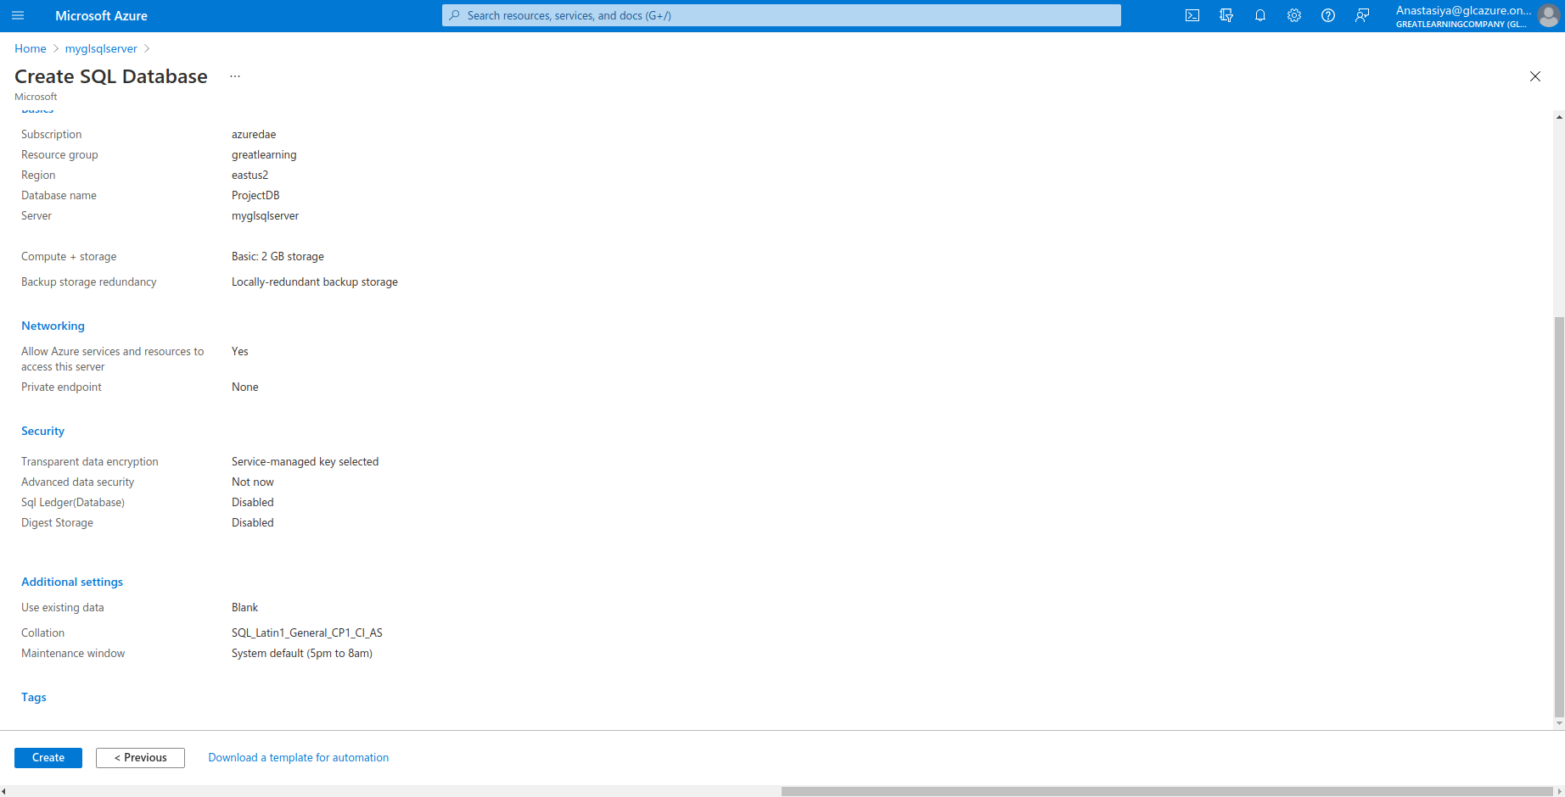

## Use the query editor to create a table with the following fields and datatypes

### a) Name: String

### b) Author: String

### c) ISBN: Integer

### d) Price: Integer

### e) Number of copies available: Integer

Because of the given values of data, espessialy 'Madness' book, only ‘Name’ column has not null values.

## Insert the values into the table

Query to insert the values

INSERT INTO [dbo].[Books] (Name, Author, ISBN, Price, Number_of_coppies_available)

VALUES

('Pet Sematary', 'Stephen King', 11011123,437,3),

('The Shining', 'Stephen King', 11679532,345,2),

('The Haunting on Hill House',' Shirley Jackson', 11659042, 550, 6),

('Dracula', 'Bram Stoker', 11011666, 250, 4),

('At the Mountains of','H.P Lovecraft', 1145873, 599, 2),

('Madness', NULL, NULL, NULL, NULL),

('Psycho', 'Robert Bloch', 1167903, 399, 6),

('The Silence of the Lambs', 'Thomas Harris', 1178902, 350,4),

('A Head Full of Ghosts', 'Paul Trembley', 1167902, 450, 7),

( 'Carrie', 'Stephen King', 1189450, 399, 4 ),

('Bird Box', 'Josh Malerman', 1123670, 500, 1);

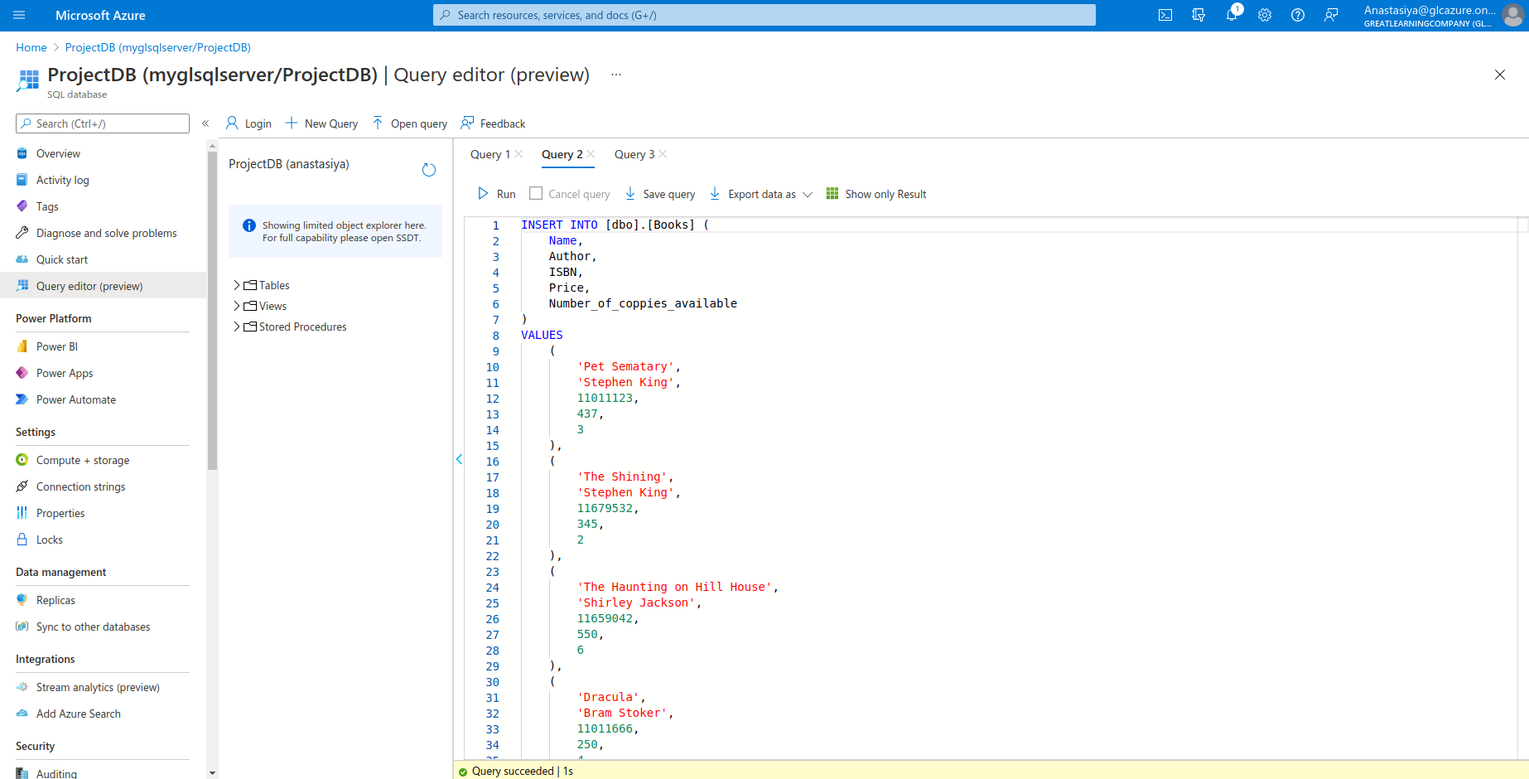

Check if all data are correctly loaded into the table ‘Books’

SELECT *

FROM [dbo].[Books];

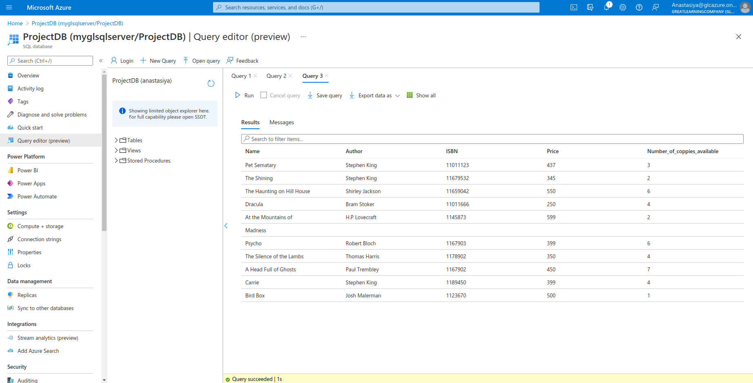

## Write queries to retrieve the following data

### a) Total price of all the books authored by Stephen King

- Price for unique books authored by Stephan King

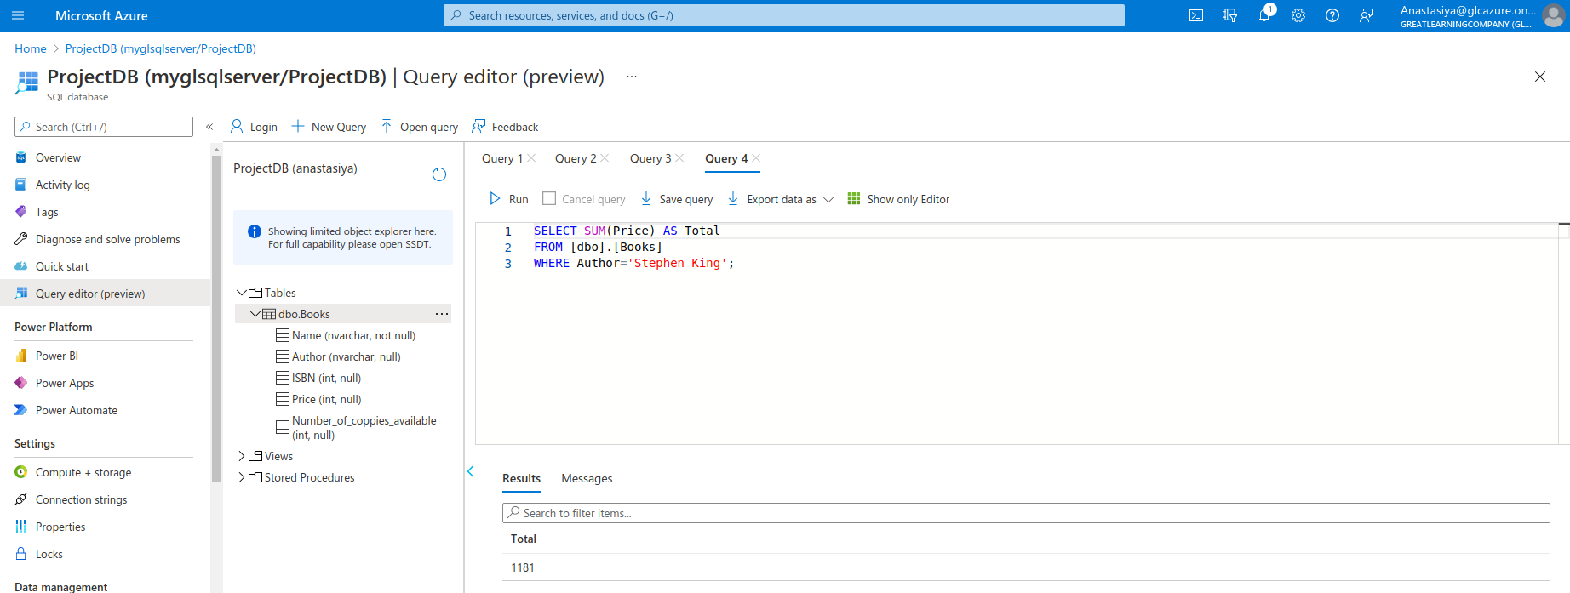

- Price for all copies of books authored by Stephan King

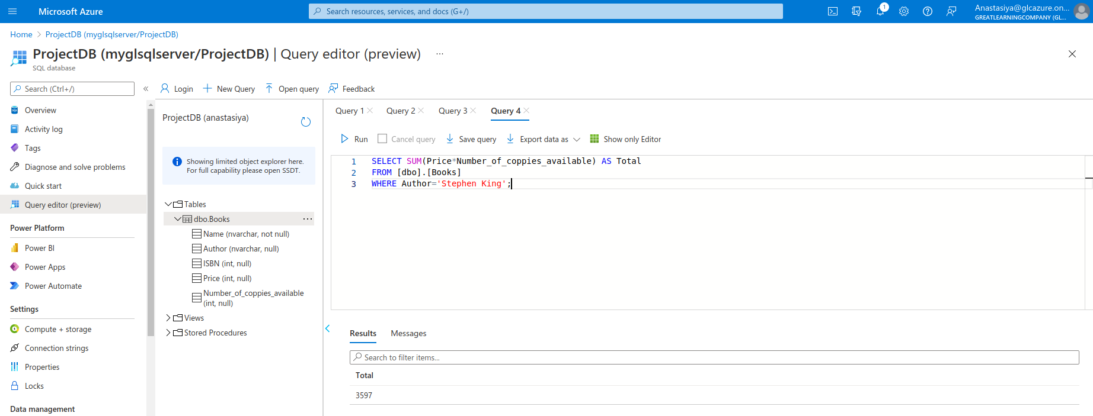

### b) List of all the Books priced above 500

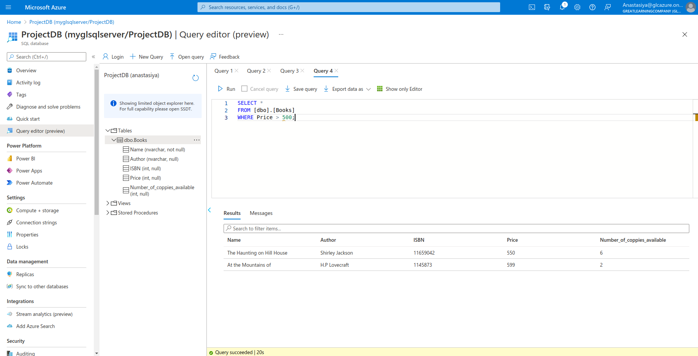According to the data, there is 2 books priced above 500

### c) Number of books with less than 3 copies available

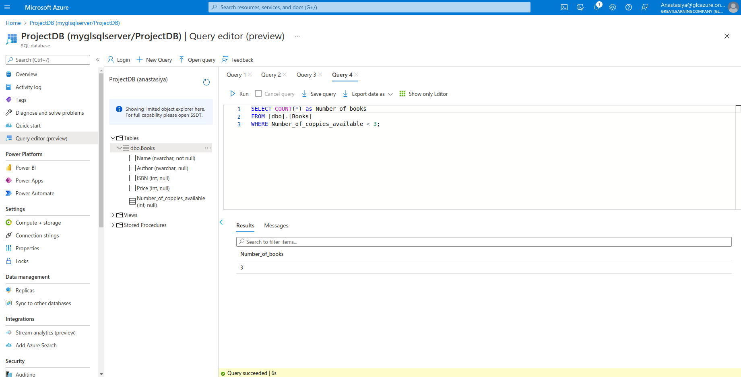There is 3 books which have less than 3 copies available.